If you’re wearing (color)…
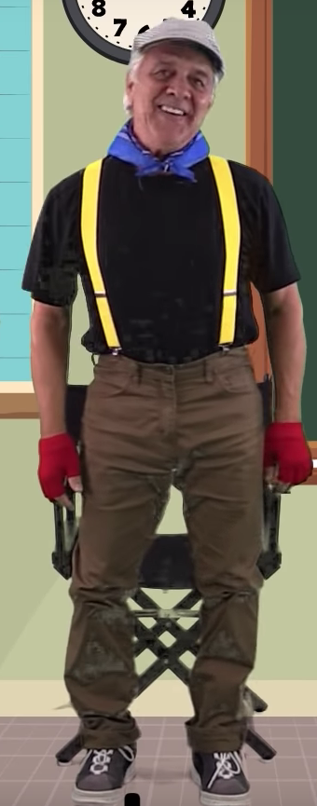
Stand up and ….
Stand up no matter
what color’s on you.
Now sit down and clap
till we sign what to do. Yeah!

Do you know these words?

shake
bow
pat
touch
spin
holler
wave
wink
reach

Youtube.com: If you’re wearing colors
https://www.youtube.com/watch?v=yxGGZq1zHqg&t=206s

