Reading reaction reports

These are four forms I use for extensive reading reaction reports.

I ask students to use each one at least one. After that, they decide which they want to use.

Having different forms (a) provides variety and (b) works with different learning styles/intelligences.

The forms are:

1. summary/ reaction
2. Draw a picture. Artistic/kinesthetic/visual.
3. Your own questions. Analytical skills. Also encourages learners to preview the book.
4. The book and you. Intrapersonal.

Feel free to modify these in anyway you like to fit your program.
This file is in .pdf format so the font-based graphics, etc. come through

Miyagi Gakuin Women's University
Sendai, Japan

march@mgu.ac.jp

http://HelgesenHandouts.weebly.com

Reading for pleasure
Reaction Report Date _____________
Your name: __________________________

Book's title
Type: (circle): non-fiction: cu - culture hs - history bio- biography
sc-science nf=other non-fiction: ______
Fiction: hm - humor my - mystery lv - love ad - adventure
sf- science fiction of- other fiction:__________
Publisher: (circle): B- Black Cat C – Cambridge Cn – Cengage
H – Heinemann N-Nat’l Geographic M - Macmillan O- Oxford
P – Penguin (Longman) S - Scholastic Other: __________
 yes no •Movie tie-in? yes no Seen it? yes no
Level: ______ Pages ______ x ______ = Weighted pages
real value (lev. 1= 0.5, lev. 2 = 0.75,
lev. 3 = 1.0, levels 4-6 – 1.25)
Reaction Report:
What the book was about?

< Write quickly.
1 minutes or less.
Don’t waste time erasing.
It is OK to cross out.

Do NOT copy
sentences from
the book.
_ _ _ _ _ _ _ _ _ _ _ _ _ _ _ _ _ _ _ _ _ _ _ _ _ _ _ _ _ _ _ _ _
What was your opinion of the book?

Evaluation: ☺ Good. I'd recommend this book to a friend.
Check(√) one 😐 Average. It was just so-so.
☹ Poor. This book was not interesting.
Reading for pleasure
Draw a picture Date _____________
Book's title Your name:
Type (circle): non-fiction: cu - culture hs - history bio- biography
sc-science nf=other non-fiction: ______
Fiction: hm - humor my - mystery lv - love ad - adventure
sf- science fiction of- other fiction:__________
Publisher: (circle): B- Black Cat C – Cambridge Cn – Cengage
H – Heinemann N-Nat’l Geographic M - Macmillan O- Oxford
P – Penguin (Longman) S - Scholastic Other: __________
 yes no •Movie tie-in? yes no Seen it? yes no
Level: ______ Pages ______ x ______ = Weighted pages  
real value (lev. 1= 0.5, lev. 2 = 0.75,
lev. 3 = 1.0, levels 4-6 = 1.25)
1. Draw a picture of a scene from the story.
Don’t copy a picture. Draw one from your imagination.

2. Explain the picture.
What is happening? What happened before this picture? What happened next?

3. Your opinion. What did you think of the book?

Evaluation: Check(√) one Good ☺ Average 😐 Poor ☹

Reading for pleasure
Your own questions Date _____________
Book's title Your name:
Type: (circle): non-fiction: cu - culture hs - history bio- biography
sc-science nf=other non-fiction: ______
Fiction: hm - humor my - mystery lv - love ad - adventure
sf- science fiction of- other fiction:__________
Publisher: (circle): B- Black Cat C – Cambridge Cn – Cengage
H – Heinemann N-Nat’l Geographic M - Macmillan O- Oxford
P – Penguin (Longman) S - Scholastic Other: __________
 yes no •Movie tie-in? yes no Seen it? yes no
Level: ______ Pages ______ x ______ = Weighted pages  
real value (lev. 1= 0.5, lev. 2 = 0.75,
lev. 3 = 1.0, levels 4-6 = 1.25)
1. Before you read.
Look through the book. Find 3 pictures. Write a different question about each.
(If there are no pictures, read the back cover. Write 3 questions.)

• page Q1: ?
◆
• page Q2: ?
◆
• page Q3: ?
◆
2. As you read, answer your questions next to the diamonds ().

3. Reaction Report:
What was the book about? What happened?

Your opinion. What did you think of the book?

Evaluation: Check(√) one Good ☺ Average 😐 Poor ☹
The story and you Date ____________
Book's title Your name:
Type: (circle): non-fiction: cu - culture hs - history bio- biography
sc-science nf=other non-fiction: ______
Fiction: hm - humor my - mystery lv - love ad - adventure
sf- science fiction of- other fiction:__________
Publisher: (circle): B- Black Cat C – Cambridge Cn – Cengage
H – Heinemann N-Nat’l Geographic M - Macmillan O- Oxford
P – Penguin (Longman) S - Scholastic Other: __________
 yes no •Movie tie-in? yes no Seen it? yes no
Level: ______ Pages ______ x ______ = Weighted pages  
real value (lev. 1= 0.5, lev. 2 = 0.75,
lev. 3 = 1.0, levels 4-6 = 1.25)
1. Think about the story. What happened?
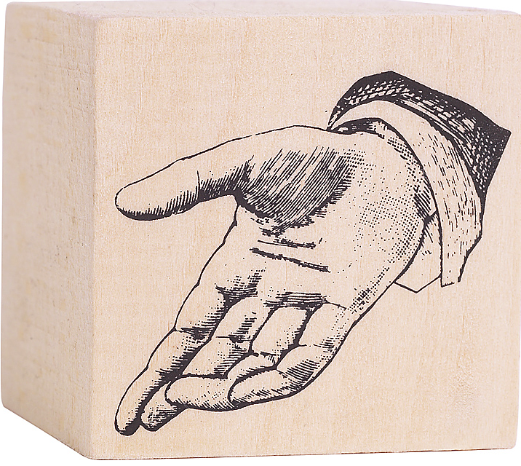
What was the same as your life? What is different?.

The story. My life.

2. Reaction Report: Your opinion. What did you think of the book? Why?

Evaluation: Check(√) one Good ☺ Average 😐 Poor ☹

